EXPERIMENT 1
Car Booking Reservation System Using Zoho One (SaaS)
Aim
To create a Car Booking Reservation System using Zoho One as a cloud-based Software as a Service (SaaS) application.
Procedure
- Create Zoho One Account – Set up the organization and create users such as Admin, Booking Manager, and Staff.
- Create Zoho Creator Application – Create a new application named Car Booking Reservation System.
- Create Car Database – Add car details such as Car ID, Registration Number, Brand, Model, Fuel Type, Rate, Location, and Availability Status.
- Create Customer Form – Store customer information including Name, Mobile Number, Email, Address, Driving License Number, and ID proof.
- Create Booking Form – Add Booking ID, Customer, Car, Pickup Date, Return Date, Location, Number of Days, Rental Amount, and Booking Status.
- Check Car Availability – Use Zoho Creator workflows/Deluge to check whether the selected car is already booked for the requested dates.
- Calculate Booking Amount – Automatically calculate rental cost, discount, tax, security deposit, and final booking amount.
- Integrate Zoho CRM and Payment – Send customer and booking information to Zoho CRM and connect a payment gateway for online payment.
- Send Confirmation and Notifications – After successful booking/payment, automatically send confirmation emails or messages containing the Booking ID, car details, pickup date, and return date.
- Manage Pickup, Return and Reports – Record vehicle pickup/return details, update car availability automatically, and create dashboards in Zoho Analytics for bookings, revenue, cars, and customers.

Implementation Input:
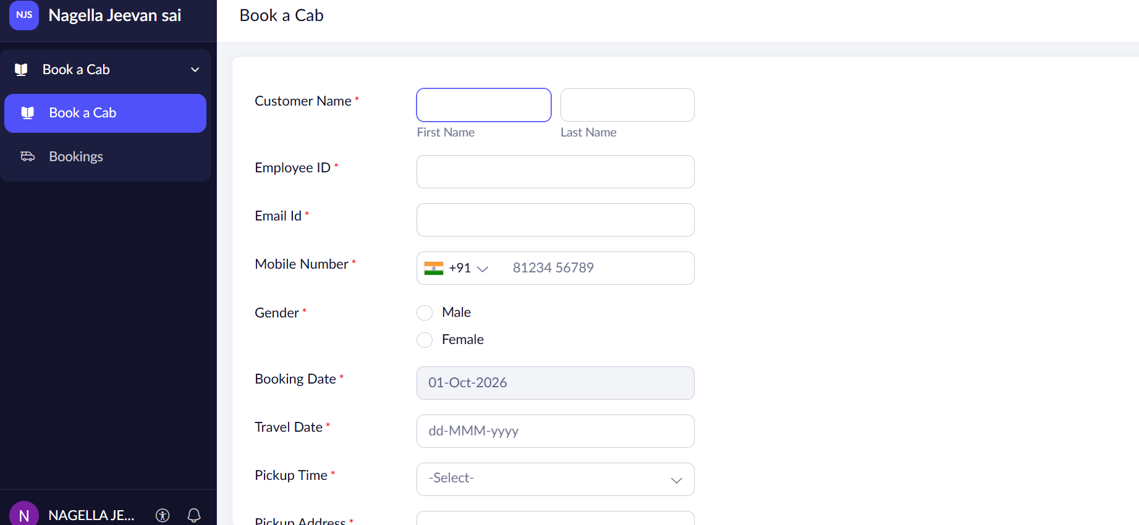
Output:
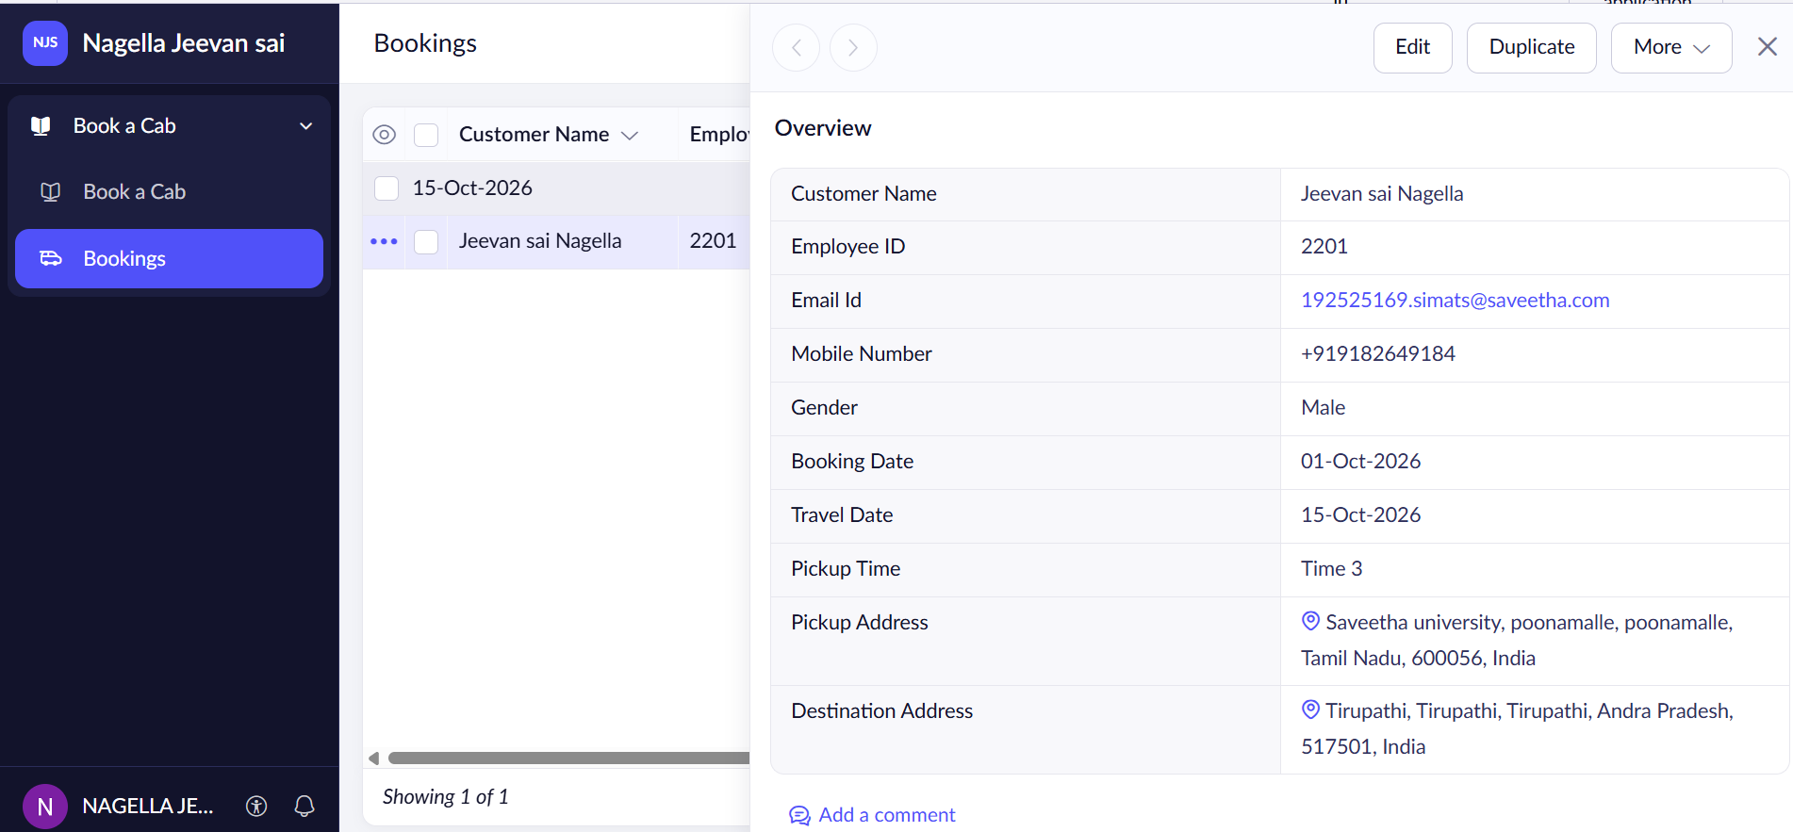

Result
Thus, a Car Booking Reservation System was successfully created using Zoho One and demonstrated as a Software as a Service (SaaS) application.

